HOTEL RESERVATION SYSTEM

Name- Rishabh Maurya
UID- 202501100100211
-- TABLE 1: CUSTOMER

CREATE TABLE CUSTOMER (
Customer_ID NUMBER PRIMARY KEY,
Name VARCHAR2(50),
Phone VARCHAR2(15)
);

-- TABLE 2: ROOM

CREATE TABLE ROOM (
Room_No NUMBER PRIMARY KEY,
Room_Type VARCHAR2(30),
Price NUMBER(10,2)
);

-- TABLE 3: RESERVATION

CREATE TABLE RESERVATION (
Reservation_ID NUMBER PRIMARY KEY,
Check_In DATE,
Check_Out DATE,
Customer_ID NUMBER,
Room_No NUMBER,

FOREIGN KEY (Customer_ID)
REFERENCES CUSTOMER(Customer_ID),

FOREIGN KEY (Room_No)
REFERENCES ROOM(Room_No)
);
INSERT INTO CUSTOMER VALUES
(1, 'Rishabh', '9876543210');

INSERT INTO CUSTOMER VALUES
(2, 'Aman', '9876543211');

INSERT INTO CUSTOMER VALUES
(3, 'Rahul', '9876543212');

INSERT INTO CUSTOMER VALUES
(4, 'Priya', '9876543213');

INSERT INTO CUSTOMER VALUES
(5, 'Neha', '9876543214');

INSERT INTO ROOM VALUES
(101, 'Single', 1500);

INSERT INTO ROOM VALUES
(102, 'Double', 2500);

INSERT INTO ROOM VALUES
(103, 'Deluxe', 3500);

INSERT INTO ROOM VALUES
(104, 'Single', 1500);

INSERT INTO ROOM VALUES
(105, 'Suite', 5000);

INSERT INTO RESERVATION VALUES
(1, DATE '2026-11-05', DATE '2026-11-07', 1, 101);

INSERT INTO RESERVATION VALUES
(2, DATE '2026-11-06', DATE '2026-11-08', 2, 102);

INSERT INTO RESERVATION VALUES
(3, DATE '2026-11-10', DATE '2026-11-12', 3, 103);

INSERT INTO RESERVATION VALUES
(4, DATE '2026-11-12', DATE '2026-11-14', 1, 104);

INSERT INTO RESERVATION VALUES
(5, DATE '2026-11-15', DATE '2026-11-17', 4, 105);

SELECT * FROM CUSTOMER;
SELECT * FROM ROOM;
SELECT * FROM RESERVATION;
SELECT
CUSTOMER.Name,
ROOM.Room_Type,
ROOM.Price,
RESERVATION.Check_In,
RESERVATION.Check_Out
FROM RESERVATION
JOIN CUSTOMER
ON RESERVATION.Customer_ID = CUSTOMER.Customer_ID
JOIN ROOM
ON RESERVATION.Room_No = ROOM.Room_No;
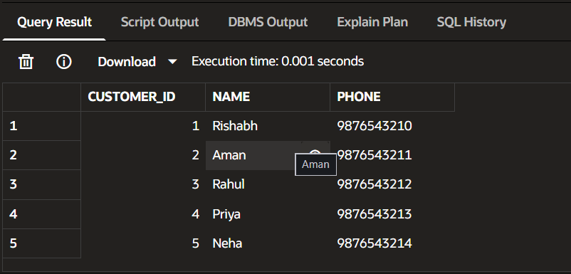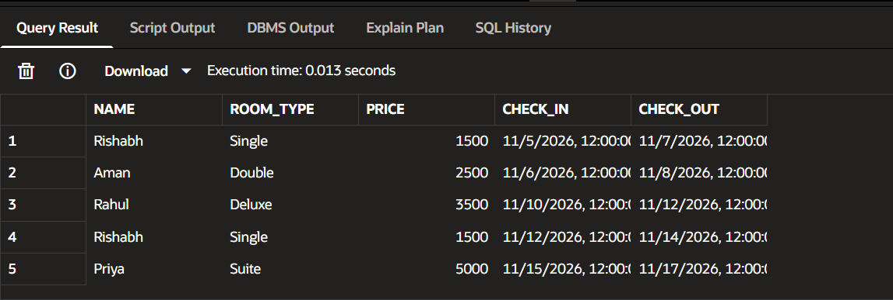
Github Link - Click Here

